IFG Explore Egg Crafts
3rd Year
2nd Term, Week Nine Interest

Aim: To create craft in the shape of an egg

Objectives:
- To complete egg shaped craft

Coaches Tip:
Pre dye some of the egg shells before this session if you choose to do the mosaic craft.

Equipment:
- Gather together equipment for chosen craft

Pre SetUp:
Organise some games for when the girls start to arrive
Set tables up and put out equipment

Set Up:
Usual set up and roll call.

Games:
Your choice of games from either the games book or ones played in the previous “egg” weeks.

Devotions:
The great famine: Genesis 41 : 53-57
For seven years, the rains had come. The crops grew green and strong, and there was more than enough to eat for everyone.
But then one day, the rains stopped.
Of course, no one noticed the day the rains stopped. That’s not something you notice. At first all those sunny days are great. But then after a while, the grass starts to turn a little brown, and the crops in the fields begin to shrivel a little. And then later on, the grass turns really brown, and the crops begin to wilt away.
And that’s how it was in the land of Egypt. The rains did not come, and the crops began to dry up and die.
Everywhere the land was thirsty for water. And there was none.
Now, you have to remember that this was a long time ago, and things were quite a bit different than they are now.
For one thing, when the sun went down at night, it got dark! There weren’t lights on everywhere like there are now because electricity wasn’t going to be invented for thousands of years. You couldn’t go to your tent and flip a switch to turn on a light, or sit down at your computer, or watch TV.
It was dark everywhere with only the light from the moon and the stars.
If you needed more light, you had to light a candle or an oil lamp, or build a fire in the fire pit.
And when you ran out of bread, you had to make more yourself. You couldn’t just hop on your camel and run up to the grocery store, where you’d find shelf after shelf jammed with all kinds of bread in fancy plastic packages.
No, you had to get out the flour and yeast and water, and light the fire in the oven and bake your own bread.
And if you ran out of flour, you had to go to the storehouse and get some more wheat and grind it up into flour.
And if you ran out of wheat in your storehouse, well, then what would you do?
If you ran out of wheat, that was it. You were in trouble.
There was no grocery store you could always run to and get more. You had to wait until the next harvest, when the wheat had grown up again.
These days it’s easy for us to think that everything comes from the grocery store. The shelves are always full. Whenever we run out of anything, there is always plenty more. It’s easy to think, Who needs God? We can just go to the store and get anything we need!
But that’s not how it really is.
Everything really comes from God.
If the rain didn’t fall, and the crops didn’t grow, the shelves in the store would be empty. And there would be nothing anybody could do.
Only God can make the rain fall and the crops grow.
But God is so good and so powerful and so loving, he takes care of us every day. He sends the rain that waters the earth. He makes the wheat for bread grow; and corn, and bananas, and oranges and carrots. He even makes fun stuff grow, like cocoa beans and vanilla so we can have hot chocolate and banana splits.
We should thank God every day; He blesses us with so much! Prayer.


Teaching Session:
Egg sun catcher craft:
Materials Needed:
Wax Paper
Grater
Old Crayons
Newspaper
Iron
Scissors
Ribbon or something similar for a hangar.

Instructions:
Cut two egg shapes from wax paper, pattern below. Lay a few sheets of newspaper on the work surface. Place one of the egg shapes on the newspaper. Turn on the iron to a low setting with no steam.
Use the grater to make shavings from old crayons. Sprinkle the shavings on the wax paper egg shape. The girls can make designs with the shavings. Once the shavings are in place, set the other egg shape on top of the shavings. Make sure the edges of the eggs match up as well as possible.
Gently place a few pieces of newspaper on top of the design. Press the newspaper on top of the egg shapes with the iron. Since all irons are different you may need to experiment with the time it takes for this project. It is complete when all the crayon shavings melt and both egg shapes stick together. Let cool, attach a hangar of ribbon or something similar and the sun catcher is ready to hang in the window!

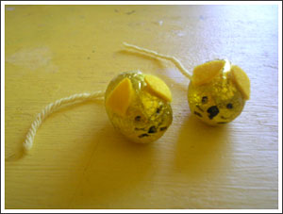
Chocolate Easter Egg animals:
Since Easter was not that long ago, you may be able to pick up some smaller chocolate Easter eggs at a cheap price.
The girls would love creating either of these two critters from small chocolate eggs.

A wool tail, felt ears and features drawn with a black marker will make an adorable mouse.

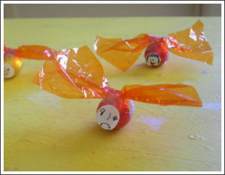
Twisted cellophane wings and a face drawn on a white circular sticker make a cute bug.

Eggshell Mosaic
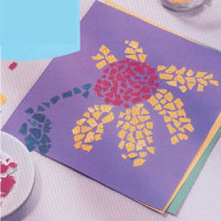
Recycle broken eggshells to create mosaics!
Equipment:
- Broken egg shells – save shells from previous weeks activities
- Food colouring and vinegar
- Heavy card
Directions:
- Rinse eggshells and break into tiny pieces
- Prepare a variety of dye colours in plastic containers by adding a few drops of food colouring to a small amount of hot water. A drop of vinegar added to the water will help to set the colour.

To dye eggshells, simply immerse them in the water. Leaving the shells in the dye for varying lengths of time will create different shades of colour to work with.

Remove shells from dyes and spread them out on paper towels to dry. When shells are dry, gather the different colours in separate containers.

The shell pieces should be arranged in the basic mosaic design before beginning to glue. When satisfied with your design, glue shell pieces into place with white glue. If desired, use a clear spray lacquer to coat the entire mosaic.

Closing Prayer

Home time & notices:

